INFO ON FOUNDERS & IDEA

☐ I am interested in a general consultation
☐ I am specifically interested in the following programs:
☐ Exist-Gründungsstipendium ☐ Exist-Forschungstransfer
☐ Junge Innovatoren ☐ VIP+

Project / idea (please fill in as far as possible)

What short name do you give your project / idea (max. 3 words)?
Your idea in 10 words...
Your idea in 50 words...
How did you come up with this business idea?
What is new about what you are planning?
Are there comparable offers / products?
How do you know that there is demand for your offer?
Free info

Founder
Copy input block, for multiple founders.

Name
Prename
Title
Education
Function in the Projekt
Telephone
Mail
Location
University/
Institution
Faculty/Institute
Chair
Free Info

EXPECTATIONS

What QUESTIONS do you have for the start-up office?

What EXPECTATIONS do you have of the advice you receive at the start-up office?

How do you know us or how did you hear about us?

If you are a student, doctoral candidate or employee of the University of Freiburg, you can also simply subscribe to our newsletter in your university account: https://myaccount.uni-freiburg.de/uadmin/login
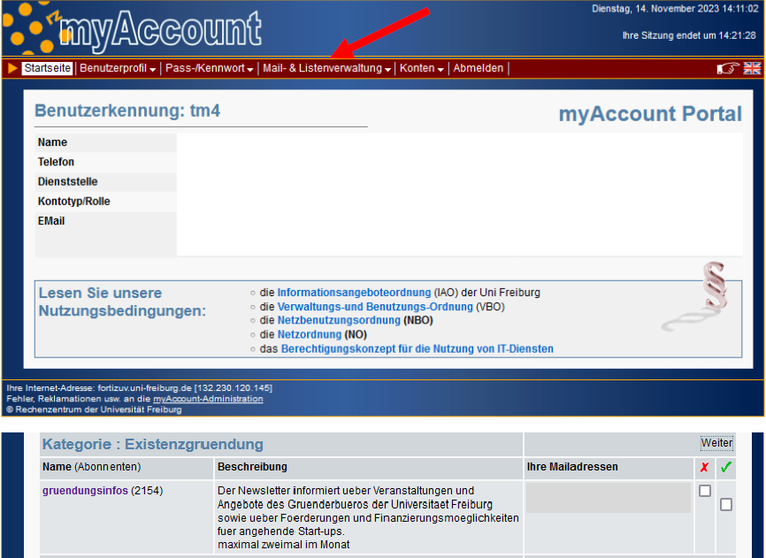

Data protection:
If you send us inquiries via the contact form, your details from the inquiry form, including the contact details you provide there, will be stored by us for the purpose of processing the inquiry and in the event of follow-up questions. We will not pass on this data without your consent.
The data entered in the contact form is therefore processed exclusively on the basis of your consent (Art. 6 para. 1 lit. a GDPR). You can revoke this consent at any time. All you need to do is send us an informal email. The legality of the data processing operations carried out until the revocation remains unaffected by the revocation.
We will retain the data you provide on the contact form until you request its deletion, revoke your consent for its storage, or the purpose for its storage no longer pertains (e.g. after fulfilling your request). Mandatory statutory provisions - in particular retention periods - remain unaffected.

